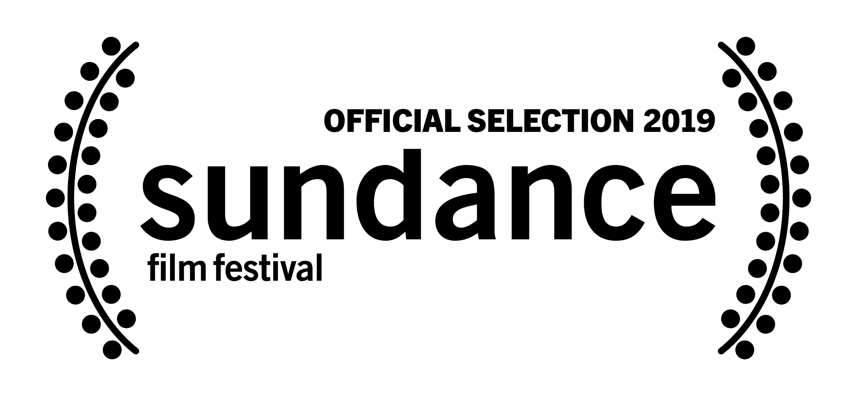
MIKE WALLACE IS HERE
A film by Avi Belkin
Produced by Rafael Marmor, p.g.a., John Battsek, Peggy Drexler
Avi Belkin, p.g.a., and Christopher Leggett

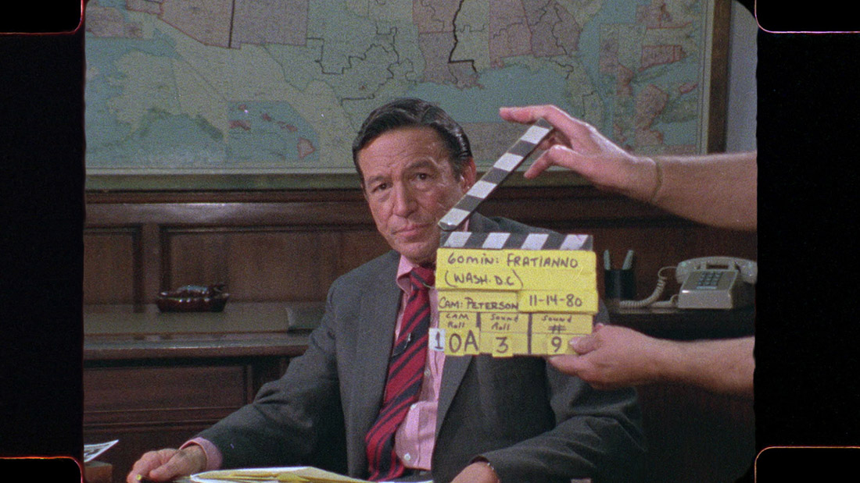

**WORLD PREMIERE – U.S. DOCUMENTARY COMPETITION - 2019 SUNDANCE FILM FESTIVAL**

Sales Contacts
CAA Media Finance
filmsales@caa.com
(424) 288-2000‬‬‬

Press Contacts
Ryan Werner  Cinetic Marketing  ryan@cineticmedia.com | Karen Oberman  Cinetic Marketing  karen.oberman@ko-pr.com

SYNOPSIS

Never before has journalism in America been so hotly debated. At a time when it seems like the hard-hitting question is fighting for its right to be asked, MIKE WALLACE IS HERE turns the tough question loose on its inventor to understand how we got here and what’s really at stake. Legendary newsman Mike Wallace unflinchingly interrogated the 20th century’s biggest figures in over fifty years on the air, and his aggressive reporting style and showmanship redefined what America came to expect from broadcasters. Unearthing decades of never-before-seen footage from the 60 Minutes vault, this documentary portrait explores what drove and plagued this restless reporter, whose storied career was entwined with the evolution of journalism itself.

“Take a look at the history of any nation which has lost its freedoms, and you’ll find that the men who grabbed the power also had to crush the free press” — Mike Wallace

We witness now on a daily basis the dangers of a fractured and disrespected press. Echo chambers abound, talking heads toe party lines, and politicians attempt to convince the public that facts—and truth—don’t matter. The sharp-edged, astute documentary MIKE WALLACE IS HERE looks for inspiration in a different time, in the work of one of the most fearless, confrontational broadcast journalists of the last 50 years… and finds motivation for those holding truth to power in the present day.

MIKE WALLACE IS HERE is told exclusively through archival footage, without one talking-head commentary or backward-looking interview diluting the immediacy and power of Wallace’s work. The film traces his career on the air from his invention of the “tough question” in his 1950s interview show Night Beat to his news specials of the ’60s and his extraordinary four decades on CBS’ 60 Minutes, examining how his genre-defining work changed the standards of broadcast journalism for good and for ill, while unpacking the personal qualities that made Mike tick.

Director Avi Belkin had unlimited access to CBS News’ archives for the making of the documentary, including never-before-seen raw materials and outtakes from 60 Minutes’ earliest days on the air. Drawing from that and other sources, including the University of Texas at Austin where Wallace’s early kinescopes are stored, he crafted the story of Wallace’s path from radio drama announcer to early TV actor-pitchman to hard-hitting journalist—an incredible career trajectory that ran parallel to, and influenced, major transformations in broadcast journalism over the course of the 20th century. “I had full access to the CBS vault and scoured thousands of hours of interviews and broadcast work. That included never-before-seen raw footage of some of the greatest interviews ever conducted, shot beautifully on Super 16mm film,” he says. “Not just 60 Minutes, but also archives of old shows, commercials, early acting jobs, and interviews other people did with Mike. This was the first time 60 Minutes and CBS News have ever opened their archives completely to an outside filmmaker. I had my pick of over 50 years of unparalleled archival footage… it was a dream.”

Belkin’s aim was to create a dialogue with his subject, who died in 2012 at the age of 93. By collecting every instance where Wallace himself was interviewed, and coupling his answers with his interrogations of others, Belkin created a framing dialectic for the film inspired by Wallace’s own trademark style. “This film interviews Mike while he’s interviewing others,” says Belkin, who began researching the film in 2016. “We got a ‘Mike Wallace interview’ using Mike’s own tools.”

Creating that meta-interview of Wallace proved no easy task, and began with Belkin watching hundreds of hours of footage and poring over thousands of pages of printed transcripts with a highlighter in hand, picking the toughest questions posed to Mike and his most revealing answers. He then repeated the process for materials where Wallace was the interviewer, honing in on themes that connected to his subject’s life and the essence of his work. From this deep research emerged a paper script, which over the course of an eight month edit period came to life in the hands of veteran documentary editor Billy McMillin, as material from innumerable sources was drawn together into a cohesive whole.

Populated by Wallace’s extraordinary sit-downs with world leaders, iconic performers, murderous gangsters, military commanders, corporate liars, and everything in-between, MIKE WALLACE IS HERE is an essential look at the journalist who captured the essence of his craft when he said that “You ask tough questions to get behind the facade, to understand what's really going on behind the scenes.”

“Interviews are a way of learning about others, and ourselves through others.”
— Mike Wallace

For over fifty years, Mike Wallace epitomized the journalist-interviewer as tough-talking truth-seeker, first in the 1950s on Night Beat (swiftly renamed The Mike Wallace Interview), then as part of the CBS News team, and then as the cornerstone reporter of television’s seminal newsmagazine 60 Minutes. In raw and previously untouched footage from archives across the country, Wallace is illuminated through the journalistic sparring matches that made him famous. He corners, argues with, cajoles, and challenges everyone from Vladimir Putin, Malcolm X, Richard Nixon, Barbra Streisand, an ’80s-era Donald Trump, and the Ayatollah Khomeini to name a few. Meanwhile, in interviews Wallace gave to his 60 Minutes colleagues and others, we see Wallace respond to the challenges and criticisms he faced in his own life.

“You can’t separate Mike Wallace the persona from Mike Wallace the person,” says Belkin. “Very early on, Mike adapted this hard-edged character called ‘Mike Wallace,’ and he played that role his entire life.”

MIKE WALLACE IS HERE resonates at a moment when journalism and the American press corps are threatened by a government intent on sowing constant doubt and spreading distrust of the media. “The idea for this film originated with a question: how did we get to the place broadcast journalism is at today?” says Belkin. “Mike was era-defining, yet he was so prescient in many ways. For him, journalism was about asking the hard questions, and in doing so, speaking truth to power. Now, the powers that be fight back against journalism. [The government] is focused on giving one very subjective point of view, with all else labeled ‘Fake News.’”

“We’re at a very precarious tipping point for broadcast journalism, where the different corridors of power are getting the upper hand,” says Belkin. “A crucial moment in the film is when Mike says ‘the first thing that totalitarians do is attack the free press.’ I wanted this film to show how the free press is imperative for a democracy, and how asking hard questions is the core of what journalism is about. Audiences today don’t want journalists to confront them with uncomfortable truths or tell them something that runs against their beliefs, and people with power take advantage of that and are fighting against the public’s right to know.”

“This pushback from the powerful against journalism is the story of the last 30 years of broadcast journalism, and now we can see where it’s becoming dangerous to our democracy,” says Belkin. “Journalism needs to have integrity. If people don’t believe in it, its power is diminished. Hopefully, by telling the origin story of broadcast journalism, MIKE WALLACE IS HERE will remind people how we’re missing journalists who are willing to fight that by asking the right questions.”

Belkin, who grew up in Tel Aviv and studied narrative filmmaking at the Midrasha Film School, worked with producers Rafael Marmor, John Battsek, Peggy Drexler, and Christopher Leggett to put together MIKE WALLACE IS HERE. Along with editor Billy McMillin, Belkin constructed a personal and professional history of their subject that provides vital insights into how Wallace fit into and influenced the changing landscape of journalism in America.

“From the beginning, I reached out to the Wallace estate, and that allowed us to go to CBS, to the University of Texas at Austin, to Mike’s alma mater the University of Michigan, to every place that held any of his work,” says Belkin. “UT-Austin had the black-and-white kinescopes of The Mike Wallace Interview that launched his hard-questioning style. They had unbelievable footage, a real treasure trove of material that helped create the full arc of the film. Those materials really show how Mike invented the direct question as we know it today, and chronicle the emergence of the new ‘star journalist’ in Mike Wallace.”

“It’s absolutely necessary to penetrate a superficial response in order to reach the truth”
— Mike Wallace

Footage from the 1950s shows Wallace—born in Brookline, Massachusetts in 1918 and already an experienced radio broadcaster shortly after graduating from the University of Michigan in 1939—hosting game shows, announcing for radio, acting in live dramas, and serving as a commercial pitchman for various products in the early days of television before landing his own one-on-one interview show for a local New York station. He hosted the groundbreaking news program Night Beat from 1956 to 1957, which was picked up nationally by ABC as The Mike Wallace Interview and gave Mike his first taste of widespread recognition.

After The Mike Wallace Interview ended in 1958, Wallace mixed entertainment- and news-hosting gigs on local TV with commercial work—until his oldest son, Peter, died in a mountain-climbing fall near Corinth, Greece, in August 1962 while on a break from Yale.

“Mike turned the hard question on himself after Peter’s death,” says Belkin. “He thought about the commercials he was doing and essentially said to himself, ‘What are you doing with your life?’ This is the moment where we see the real purpose of the hard question: to create a moment of reflection and truth that triggers a change for the better. Mike responded by committing to the version of himself he developed on Night Beat—that ‘Mike Wallace’ who asked tough questions and never backed down from debate. Really, the person he was always meant to be.”

The death of Peter Wallace—who had an interest in journalism, as did his younger brother, Fox News’ Chris Wallace—brought about a change in his father. “When Mike came to CBS News in 1963, he was a different animal,” says Belkin. “He didn’t really come from a broadcast news background—he came from a performance background. Because of that disparity, his lack of formal education, he had a chip on his shoulder—and people with chips on their shoulder often work harder. Mike always felt like he had to prove himself. Yet everything he did before he came to CBS News was exactly what created the Mike Wallace phenomenon and gave him an edge in the conservative world of broadcast news back then.”

In 1968, Wallace was approached about “a magazine for television” that CBS was developing. The title conveyed a sense of urgency with a promise of in-depth analysis: 60 Minutes. “Many times, you prepare your whole life for something, and then opportunity shows up,” says Belkin. “That’s what 1968 was for Mike Wallace. He and 60 Minutes changed journalism forever.”

But schedule changes and frequent preemptions initially kept 60 Minutes from becoming an instant success. “60 Minutes had to fight to find its footing,” says Belkin, “but it absolutely reinvented the news.” The post-Watergate 1970s popularized, and at times polarized, Wallace’s distinctive style: aggressive, combative, unbowed by those with money or power, and fearless in pursuit of the truth.

“Don’t confuse anger and hostility with an insistence on getting to the bottom line, to the fact.” — Mike Wallace

“When I was watching Mike’s raw interviews, all of that extended footage, his magnetism and style was so evident,” says Belkin of one jaw-dropping aspect of MIKE WALLACE IS HERE. “He was always ‘on,’ every moment of the interview.”

“My favorite follow-up question of Mike’s was often just one word: ‘Why?’ In that one word, he conveyed so much. This goes back to his background as an actor; he understood that an interview is drama. Over hundreds of hours spent watching them, I never saw an interview of Mike’s that was boring. He filled each one with drama to capture an audience’s attention—but he was also genuinely fascinated by the people sitting in front of him. He wanted to know what made them tick.”

“Mike was not a reflective person,” Belkin says. “I believe that the best way he could learn about himself was through his interviews of others, though his questions. So Mike’s questions were often a reflection of his own subconscious, and that’s why you see a lot of the same motifs returning over and over again in his interviews. I think the main reason Mike was so relentless in trying to get to the core of the person he interviewed was because he believed it would echo some truth in him as well.”

The film examines how copycats of Wallace’s dramatic style turned toward sensationalism, inverting what he was all about. “A lot of people imitated Mike, but they didn’t understand the substance of what he did,” says Belkin. “They just took a basic idea of ‘performance.’ But they took it to an extreme level.” In the film, we see one such copycat, Bill O’Reilly, memorably face off against Wallace.

Amidst Mike’s incredible interviews, MIKE WALLACE IS HERE details two instances when CBS News and the entire journalism world were rocked by unprecedented pushbacks. First came a 1982 libel lawsuit filed against CBS and Wallace by retired U.S. Army Gen. William Westmoreland, disputing a report about Westmoreland’s actions in Vietnam decades earlier. This had a chilling effect on investigative news organizations, which was made crystal clear in 1996 when CBS’s corporate side tried to kill a story about the tobacco industry whistleblower Dr. Jeffrey Wigand at the urging of cigarette manufacturer Brown & Williamson. “Mike said that the Westmoreland case and others like it intimidated the big corporations that owned networks, and he was right. The real intention in those cases was to deter other journalists. But Mike wasn’t going to take orders from anybody.”

MIKE WALLACE IS HERE incorporates several no-holds-barred interviews that Wallace gave to his 60 Minutes cohorts, in which he addresses the serious depression that he grappled with throughout his life, and that was especially exacerbated by the Westmoreland case. Says Belkin, “A person with depression often hides the truth, yet it’s fascinating that all Mike did during his entire life was try to uncover the truth from the people in front of him.”

“A nation’s press is a good yardstick for a nation’s health.” — Mike Wallace

That journalistic trait of never settling for less than the truth is needed in today’s political climate in ways that might astound Wallace. In one interview from late in his life, the veteran newsman says he believes the country is getting worse. The look on his face is wary, and full of the knowledge he’s accumulated from a lifetime of dogged inquiry.

“I think the responsibility for better journalism has to partly go back to the audience,” says Belkin. “They need to understand what journalism is about. A lot of people don’t know—or maybe they forgot—what hard-hitting journalism was like in the era of Mike Wallace, and what an important role it can play in our lives.”
# # #
ABOUT THE FILMMAKERS

AVI BELKIN, Director, Producer

Raised in Tel Aviv, Avi Belkin is a creative, hands-on filmmaker working across documentary and fiction as a director, writer, editor, and producer. His debut film Days, a short narrative story of a routine day in the life of a holocaust survivor, played in the official selection of Israel’s International Film Festival Ashdod in 2007. That same year, his short documentary Tunnel was shortlisted for the Oberhausen International Film Festival. He followed up with 2008’s Elephant Graveyard, winning Best Short Fiction Film at Los Angeles’ Jewish Film Festival and playing widely at festivals across Europe and North America. His documentary feature Winding, which tells the story of Israel’s infamous river Yarkon, debuted in 2015 on Israel’s Yes Docu TV channel and won Best Documentary Feature at the International Movie Film Festival in Haifa. Avi is currently directing a new true crime series with Delirio Films and Blumhouse for AMC. “Mike Wallace is Here” is his debut English-language feature.

RAFAEL MARMOR, Producer

Rafael Marmor is the founder of Delirio Films, a boutique production company specializing in feature documentaries, docuseries and commercials. His first feature documentary Blue Blood was released theatrically by Warner UK before its broadcast premiere on BBC’s Storyville. He went on to produce a number of films including Alma Har’el’s Bombay Beach, which won the Grand Jury Prize at the 2010 Tribeca Film Festival; No Place On Earth, which premiered at the 2012 Toronto Film Festival before its nationwide theatrical release; and The Short Game, which won the audience award at the 2013 SXSW Film Festival and was picked up as Netflix’s first Original Documentary. His next film, Can You Dig This, won the Grand Jury Prize at the 2015 LA Film Fest before being released theatrically in over 30 cities. In 2017, he produced the SXSW audience award winner Becoming Bond as well as Too Funny To Fail as part of Hulu’s first original documentary slate. He executive produced the six-part documentary series, Hunting ISIS, which premiered this past spring on the History Channel, and is currently executive producing a six-part true crime series for the Sundance Channel. His documentary Ask Dr. Ruth and his scripted film Honey Boy will premiere alongside Mike Wallace Is Here at the Sundance Film Festival in 2019.

JOHN BATTSEK, Producer

John Battsek runs Passion Pictures, a double Academy Award winning (four times Academy Award nominated) independent production company and one of the most successful and prolific producers of feature documentary films in the international marketplace. In 1999, Battsek conceived and produced Academy Award-winning One Day in September and he has since been responsible for multiple high profile feature documentaries. These include: Academy Award nominated Restrepo; The Tillman Story (Winner Best Historical Doc Emmy 2012); Prime Time Emmy winning Manhunt; BAFTA Outstanding Debut Winner The Imposter, and Academy Award and BAFTA winning Searching For Sugarman.

Battsek also produced Peabody-winning and 2016 BAFTA nominated Listen To Me Marlon, and the 2016 Academy Award Nominated Winter on Fire. More recently, Battsek produced Eric Clapton: Life in 12 Bars; The Final Year, which offered an unprecedented look at the shaping of US foreign policy of former US President Barack Obama’s administration; and Studio 54, the real story behind the greatest club of all time which premiered at Sundance in 2018. Battsek has been nominated three times for a PGA Award and was the recipient of 2013 prestigious Grierson Trustees Award for Outstanding Contribution to Documentary.

PEGGY DREXLER, Producer

Research psychologist Peggy Drexler, Ph.D., formed Drexler Films in 2017 as a way to educate viewers about iconic figures and critical social issues. She has executive produced Ask Dr. Ruth, recently acquired by Hulu, and produced Mike Wallace is Here and The Fight, about the ACLU. As an investor in Impact Partners, she has helped fund such films as Won’t You Be My Neighbor? and Of Fathers and Sons, which is shortlisted for an Academy Award. Dr. Drexler has also authored two books about gender and the family and is a frequent contributor to the Wall Street Journal and CNN.

CHRISTOPHER LEGGETT, Producer

Christopher Leggett is a partner at Delirio Films, a Los Angeles-based film, television, and commercial production company. Leggett began his producing career at NBC / Universal Sports, covering three Olympic Games, and was the creator of Against the Tide, an original six-part series, during his tenure. From there, Chris segued into independent production. Leggett’s first producing credit at Delirio Films, The Short Game, won the Audience Award at the 2013 SXSW Film Festival and was picked up by Netflix as their first Original Documentary. His documentary LoveTrue premiered at the 2016 Tribeca Film Festival and won the Jury award for Best Documentary at Karlovy Vary. In 2017, Delirio Films partnered with Hulu to launch its Original Feature Documentaries with Too Funny To Fail and Becoming Bond, which won the SXSW Audience award. Leggett was executive producer on a six-part documentary series, Hunting ISIS, which premiered this past spring on the History Channel and Viceland. His first scripted film, Honey Boy, written by and starring Shia LaBeouf, will premiere alongside his documentaries Mike Wallace Is Here and Ask Dr. Ruth at Sundance Film Festival in 2019.

BILLY McMILLIN, Editor

Billy McMillin has spent over a decade as a writer and editor crafting a diverse mix of stories—from war-torn life in Academy Award Nominee Iraq in Fragments, to an epic search for justice in West of Memphis, to a quest for greatness amongst the world's best 7-year-old golfers in The Short Game. He edited Hulu’s original documentaries Becoming Bond and Too Funny To Fail, and led a team of editors on History & Viceland’s docuseries Hunting ISIS.

ABOUT DELIRIO FILMS (11/29/18)

Delirio Films is a boutique production company with a focus on prestige documentary, both features and series. Over 10 years, it has built a library of films striving for a unique combination of artistic integrity and commercial viability. Delirio's titles include Alma Har’el’s LoveTrue and Bombay Beach, Magnolia Films’ No Place On Earth, Netflix’s first original film, The Short Game, and Sundance Audience Award winner The Green Prince. Recently, the company produced SXSW Audience Award Winner Becoming Bond and Too Funny To Fail, which marked Hulu’s launch into original documentaries. In 2018, it premiered the six-part docuseries Hunting ISIS on the History Channel and Viceland, following American volunteers who smuggled their way into Syria and Iraq to fight against ISIS. Delirio will premiere three new films at the upcoming Sundance Film Festival; alongside Mike Wallace Is Here, it will present Ask Dr. Ruth, a documentary chronicling the incredible life of America’s favorite sex therapist, Dr. Ruth Westheimer; and Alma Har'el's highly anticipated first narrative feature film, Honey Boy, written by and starring Shia LaBeouf.

ABOUT PASSION PICTURES

Passion Pictures’ first feature documentary One Day In September was conceived and produced by John Battsek and went on to win an Academy Award® in 1999. Passion has since been at the forefront of feature documentary production – as evidenced by a prolific run of multi-award winning films, a reputation for securing international theatrical releases, and – as of 2019 – an unprecedented fourteen consecutive years premiering films at the prestigious Sundance Film Festival.

Notable titles include: Restrepo, The Tillman Story, The Imposter, Sergio, Searching For Sugar Man, Winter On Fire , Listen To Me Marlon and Eric Clapton: Life In 12 Bars – these films and others see Passion collaborate with some of the most exciting filmmakers, writers, journalists, editors, composers, cinematographers and production partners working in the industry today.

FUN FACTS
- Total Footage: 698 hours (almost 1 month of uninterrupted content)
- Total Transcript Pages: 11,511
- Mike as an interviewee: 91 total interviews, 3,676 pages of transcripts
- Mike’s 60 Minutes Stories: 1,071 total stories by Mike, 5,606 pages of transcripts
- Outtakes from Mike’s 60 Minutes Interviews: 1,363 pages of transcripts
- Night Beat / The Mike Wallace Interview: 73 total interviews, 866 pages of transcripts

CREDITS

Drexler Films Presents
A Delirio Films Production
IN ASSOCIATION WITH
Passion Pictures
Rock Paper Scissors Entertainment
PRODUCED BY
Rafael Marmor, p.g.a.
John Battsek
PRODUCED BY
Peggy Drexler
PRODUCED BY
Avi Belkin, p.g.a.
Christopher Leggett
EXECUTIVE PRODUCER
Angus Wall
CO-PRODUCER
Zoë Morrison
EDITED BY
Billy McMillin
DIRECTED BY
Avi Belkin
End credit title cards:
A FILM BY
Avi Belkin
PRODUCED BY
Rafael Marmor, p.g.a.
John Battsek
PRODUCED BY
Peggy Drexler
PRODUCED BY
Avi Belkin, p.g.a.
Christopher Leggett
EXECUTIVE PRODUCER
Angus Wall
CO-PRODUCER
Zoë Morrison
EDITED BY
Billy McMillin
SPECIAL THANKS TO
The Peggy and Millard Drexler Family Foundation
ASSOCIATE PRODUCER
Natalie Goldberg
OFFICE PRODUCTION COORDINATOR
Kim Rogers
ASSOCIATE EDITOR
Kevin Otte
ASSISTANT EDITORS
Franz Königswieser
Ludmil Kazakov
Adam Pearson
Remberto Ramos
POST PRODUCTION SUPERVISOR
Ian Rose
POST PRODUCTION CONSULTANT
Kevin Payne
POST PRODUCTION ASSISTANTS
John Leo O'Rourke
Lacey Seebinger
POST PRODUCTION INTERNS
Julie Gould
Gretchen Grefe
Kira Tityuk
Max Mezger
Shujia Li
Ashley Lanuza
Wyatt Muma
Sophie Speciale
RESEARCHER
Steven Zax
ARCHIVAL PRODUCERS
Gideon Kennedy
Jeffrey Kanjanapangka
Susan Ricketts
Samantha Kerzner
Jessica Berman Bogdan
ARCHIVAL CONSULTANT
Rich Remsberg
60 Minutes footage courtesy of CBS News
SENIOR PRODUCER, CBS NEWS
Alison Pepper
COORDINATING PRODUCER
Sasha Reuther
CBS NEWS ARCHIVES
Roy Carubia
Michael Kivlehan
Joseph Alessi
Vincent Cammisa
Derrick Owens
Larry Jackson
John Binninger
Andrew Kasny
Robert Pechin
Daniel Perino
Anddy Matos
Dylan Gordon
RIGHTS & CLEARANCES
Josh Ravitz
Leah Hodge
Frank Spain
BUSINESS AFFAIRS
Travis Pierson
VFX by STELLAR HAWK, Inc.
VFX DIRECTOR
Joe Vaccarino
VFX DESIGNER
Steven Scott Nelson, Jr.
VFX ASSISTANT
Daisy Jane Galve
Post-Production Sound Services by SNAPSOUND
SOUND SUPERVISOR
Zach Seivers
CO-SUPERVISING SOUND EDITORS
George Pereyra
Richard N. Shapiro
RE-RECORDING MIXER
Zach Seivers
Digital Intermediate by DIFFERENT BY DESIGN
DIGITAL INTERMEDIATE COLORIST
Brian Hutchings
ONLINE EDITORS
Sean Meyers
Harry Locke IV
DIGITAL INTERMEDIATE PRODUCERS
Matt Radecki
Greg Lanesey
MUSIC
ADDITIONAL MUSIC BY
John Piscitello
SCORING MIXER
Erik Swanson
"Tick of the Clock"
Written by Johnny Jewel
Performed by Chromatics
Courtesy of Italians Do It Better Records
MATERIALS COURTESY OF
CBS News
Ira Gallen
ABCNEWS VideoSource
CNN
Getty Images
NBCUniversal Archives
WNET / Thirteen Productions, LLC
Pauline Dora / Estate of Mike Wallace
Wazee Digital
Harry Ransom Center, The University of Texas at Austin
Home Box Office, Inc / ”Dead Blue: Surviving Depression”
National Geographic Image Collection
“Frontline: Smoke in The Eye”, Mike Wallace interview ©1996 WGBH Educational Foundation
WTTW Chicago
F.I.L.M Archives
NewsHour Productions, LLC
Footage from Commonwealth Edison “O’ Hare” courtesy of The Chicago Film Archives
Retro Video, Inc
Oddball Films, Inc
"The Dick Cavett Show"
Courtesy of Daphne Productions / Global ImageWorks
C-SPAN
Footage from Studio One - Courtesy of CBS Broadcasting Inc
Niki Patton & Charles Silberstein
Pond5
John E Allen Archive
University of Michigan, Bentley Historical Library
Reelin’ In The Years Productions
Public Schools of Brookline, Brookline, MA
Paul Brownstein Productions
ADDITIONAL MATERIALS FROM
Vanderbilt University
Fox News
Texaco Star Theater / Carl Reiner / Sid Caesar Estate
Westinghouse Broadcasting
Prelinger Archives
InfoWars
Archive.org
Comedy Central
A&E
WRKO
CUNYTV75
Media Burn
Paramount Domestic Television
Charlie Rose LLC
20th Century Fox Television
King World
Deadspin
WLIW21 Public TV
TV Guide
Fox10 Phoenix
Warner Brothers TV
Freedom Forum First Amendment Center at Vanderbilt University ; presented by WHMM, Howard University Public Television
CNBC
NBC Entertainment
The Faye Emerson Show
WXYZ
Al Jazeera
The Jack Benny Estate
TRANSCRIPTION SERVICES
POV Pictures, LLC Echotext
Santa Monica Video LADB
Visual Data Media Services GoTranscript
TRANSLATION SERVICES
Masoud Mohammadi Farbod Papen
Kira Tityuk
PRODUCTION ACCOUNTING
Type A, Inc.
Angela McLain
Guillermo Murcia
Samantha Zanesco
CERTIFIED PUBLIC ACCOUNTANTS
Leggett & Leggett, CPA
David Leggett
Kimberly Leggett
SALES COUNSEL
CAA Media Finance
PRODUCTION INSURANCE
Front Row Insurance
Doug Hodges
Tina Ortiz
PRODUCTION COUNSEL
Gray Krauss
Sandler Des Rochers, LLP
Jonathan Gray, Esq.
Amy Stein, Esq.
Josephine Dongbang, Esq.
CLEARANCE COUNSEL
Donaldson + Callif, LLP
Lisa A. Callif, Esq.
Alexandre Yousefzadeh, Esq.
AUDIO RESTORATION BY
DuArt
POST PRODUCTION EQUIPMENT BY
Facilis Terrablock Apple
Adobe Premiere Pro Avid
SPECIAL THANKS
Andrew Ruhemann
Arie & Miri Belkin
Chris Wallace
Pauline Dora
Jeff Fager
Amanda Lebow
Eames Yates
David Sloan
Eames Yates, Jr.
Nancy Gauss
John Parsons
Dahlia Kozlowsky
Diana Bachman
Michael Puretz
Steve Wilson
Barbara Drury
Elias Zavada
Morgan Hertzan
Beth Knobel
The American Genre Film Archive
Celina DeNicola
Anthony Perrone
Lisa Sherman
Jennifer Sherwood
Elise Pearlstein
Zeke Margolis
Tanya Mallean
Gabriel Brakin
Josh Lukaris
Inbal Ayzenshtat
Dan Geva
Marion Cohn
Ilana Rabin
Joe Saltzman
Warren Lustig
Avi Levi
David & Kimberly Leggett
Jessica Leggett
Bruce & Beverly Marmor
Jessica Marmor
Copyright © 2019 One on One Films, LLC. All Rights Reserved.
MIKE WALLACE IS HERE

